Advance Excel Assignment 1

1. **What do you mean by cells in an excel sheet?**

Every worksheet is made up of thousands of rectangles, which are called cells. Cells are the basic building blocks of a worksheet. A cell is the intersection of a row and a column—in other words, where a row and column meet.

Columns are identified by letter (A, B, C) while rows are identified by numbers (1,2,3). Each cell has its own name or cell address based on its column and row. In the example below, the selected cell intersects column C and row 5, so the cell address is C5.

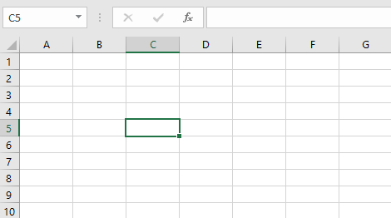

The cell address also appears in the Name box in the top-left corner, and that a cell's column and row headings are highlighted when the cell is selected.

1. **How can you restrict someone from copying a cell from your worksheet?**

By default, when you protect a worksheet, all the cells on the worksheet are locked, and users cannot make any changes to a locked cell.

To set a password to protect cells, follow the steps given below:

1. Go to REVIEW tab and click on "Protect Sheet" option.
2. Excel opens the Protect Sheet dialog box. By default, Excel selects the Protect Worksheet and Contents of Locked Cells check box.
3. Select any of the check boxes in the Allow All Users of This Worksheet To list box (such as Format Cells or Insert Columns) that you still want to be functional when the worksheet protection is operational.

The Select Locked Cells and Select Unlocked Cells check boxes are selected by default.

1. Type the password in the 'Password to unprotect Sheet' text box.
2. Click OK.
3. Excel opens the Confirm Password dialog box. Re-enter the password in the Re-enter Password to Proceed text box and then click OK. Notice that if you try to edit a cell, Excel displays an error message.

- To remove worksheet protection, click the Unprotect Sheet button in the Changes group on the Review tab. You’ll be prompted to type the password that you had set for protection.

1. **How to move or copy the worksheet into another workbook?**

Method 1: Copy Excel sheet by dragging

Usually, you drag-and-drop to move something from one place to another. But this method also works for copying tabs and is, in truth, the fastest way to copy a sheet in Excel.

Simply, click on the sheet tab that you want to copy, hold the Ctrl key and drag the tab where you want it:

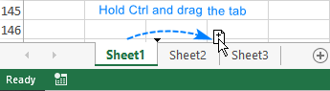

Method 2: Duplicate a sheet by right-clicking

Here's another way to duplicate a sheet in Excel that is just as easy:

Right click on the tab and select Move or Copy from the context menu. This will open the Move or Copy dialog box.

Under Before sheet, choose where you want to place the copy.

Put a tick in the Create a copy box.

Click OK.

For instance, that's how you can make a copy of Sheet1 and place it before Sheet3:

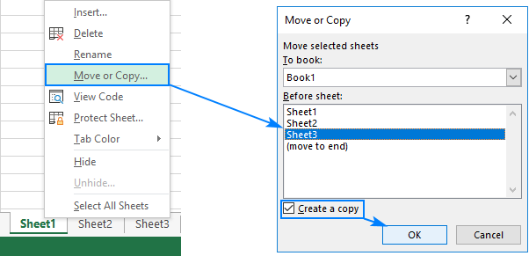

Method 3: Copy a tab in Excel using the ribbon

To copy a sheet, go to the home tab > Cells group, click Format, and then click Move or Copy Sheet:

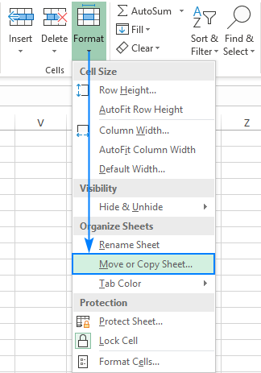

The Move or Copy dialog box appears, and you follow the same steps as described above.

The common way to copy a sheet to another workbook is this:

Right click on the tab that you want to copy, and then click Move or Copy…

In the Move or Copy dialog box, do the following:

Under To book, choose the target file. To place a copy into a new workbook, select (new book).

Under Before sheet, specify where to put the copy.

Select the Create a copy box.

Click OK.

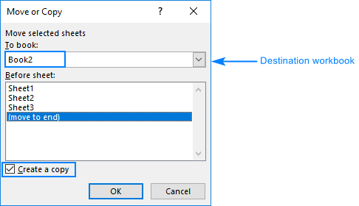

Copy a sheet to another workbook by dragging

1. Open the source and target workbooks.
2. On the View tab, in the Windows group, click View Side by Side. This will arrange the two workbooks horizontally.
3. In the source workbook, click the sheet tab you'd like to copy, hold down the Ctrl key and drag the sheet to the target workbook. 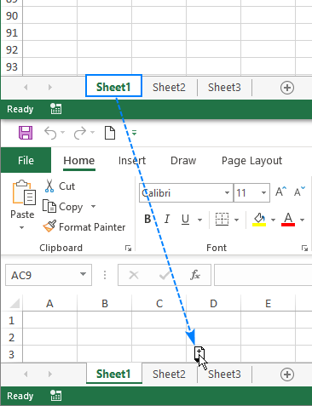

Copy multiple sheets in Excel

All the techniques that work for duplicating a single sheet can be used to copy multiple sheets. The key thing is to have several worksheets selected.

1. To select adjacent sheets, click on the first sheet tab, press Shift, and click on the last tab.
2. To select non-adjacent sheets, click on the first sheet tab, press Ctrl, and click the other tabs one by one.

With multiple worksheets selected, do one of the following to copy them:

1. Click on any of the selected tabs, press Ctrl and drag the tabs to the desired position.
2. Right-click any of the selected sheets and click Copy or Move. Then, carry out same steps as mentioned above.

Copy Excel sheet with formulas

Generally, you copy a sheet containing formulas like any other sheet. The formula references adjust automatically in a way that works just fine in most cases.

If a sheet with formulas is copied within the same workbook, the formulas will refer to copied sheet unless you use external cell references that point to another sheet or workbook. For example: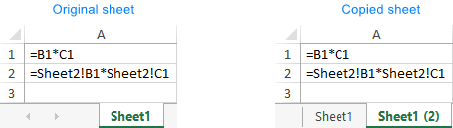

If you copy a sheet with formulas to another workbook, the formula references behave in this way:

References within the same worksheet, either relative or absolute, will point to the copied sheet in the destination workbook.

References to other sheets in the original workbook will still point to the worksheets in the original workbook. In the screenshot below, please notice that the original file name [Book1] appears before the sheet name the third formula in the copied sheet: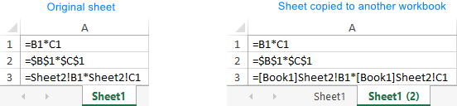

For the copied formulas to refer to the sheet with the same name in the destination workbook, you can simply remove the original workbook name by using the Replace All feature of Excel. Here's what you need to do:

1. On the copied sheet, select all the formulas you want to change.
2. Press Ctrl + H to open the Replace tab of the Find and Replace dialog.
3. In the Find what box type the name of the original workbook exactly as it appears in your formulas. In our case, we'd type [Book1].
4. Leave the Replace with box blank.
5. Click Replace All.

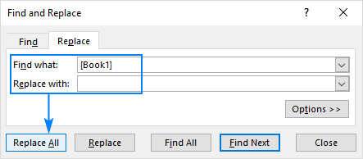

As the result, the formula in the copied sheet will change from

=[Book1]Sheet2!B1*[Book1]Sheet2!C1

To

=Sheet2!B1*Sheet2!C1

Workbook Manager - quick way to move and copy sheets in Excel

1. **Which key is used as a shortcut for opening a new window document?**

Ctrl+N

1. **What are the things that we can notice after opening the Excel interface?**

After opening excel and selecting the blank document you can see the below interface

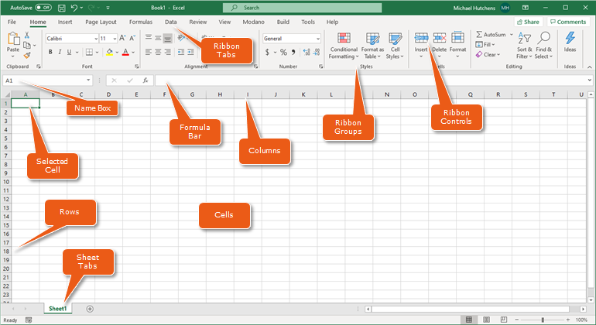

Going from the top we can see

Ribbon tabs are on the top and below them are the related ribbon groups and controls.

Then below them we can see the selected cell name and formula bar.

And then we see the worksheet with rows and columns consisting of many cells

Below the worksheet is the sheet tab bar highlighting the name of the sheet that we are working on.

1. **When to use a relative cell reference in excel?**

Relative references are especially convenient whenever you need to repeat the same calculation across multiple rows or columns.

Relative reference is the default cell reference in Excel. It is simply the combination of column name and row number without any dollar ($) sign. When you copy the formula from one cell to another the relative cell address changes depending on the relative position of column and row.